# Durable Furnitures

Artistica

## French Country Oval Coffee Table

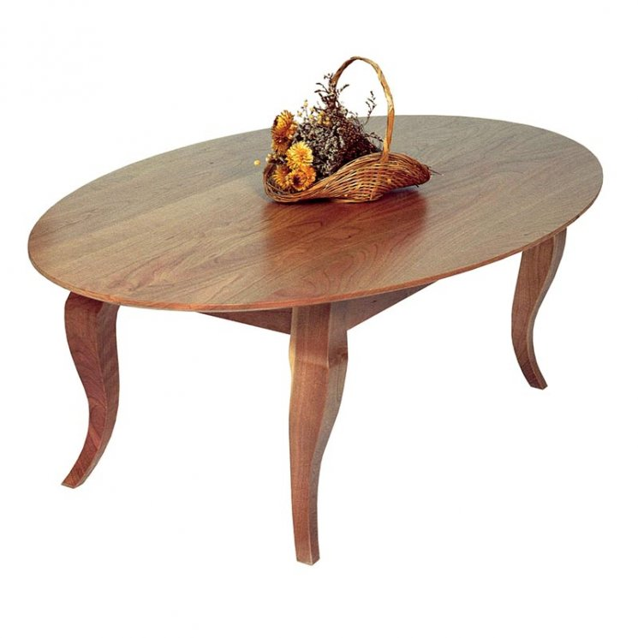

Our high-end, solid wood French Country Coffee Table is perfect for your upscale living room, den or study. The perfect piece on which to place a drink, store your favorite book or rest your feet.